Traffic challan

--------------------------------

Team members:

Siva Sathvik Chandu.Medasani Aditya Sriram.Genikala

Siri Krishna

Title: Traffic challan

Aim:

To collect and preserve the data of the traffic violations committed by the citizens. Making it available for future references and to know about the status of challans (due or clean).

Abstract:

Transport has been an essential part of our life. In the scenario of increasing population and busy lifestyles, we are coming across so much news about tragedies of accidents. Neglecting basic rules and some safety measures is the main reason behind the accidents. India ranks 1st in the number of road accident deaths across the 199 countries reported in the World Road Statistics, 2018 followed by China and the US. As per the WHO Global Report on Road Safety 2018, India accounts for almost 11% of the accident-related deaths in the World. A total of 4,49,002 road accidents have been reported by States and Union Territories (UTs) in the calendar year 2019, claiming 1,51,113 lives and causing injuries to 4,51,361 persons. This project is based on collecting and storing the data of such violations of rules so that issuing fines and counselling could cause awareness among people. Special mention, new safety gear also includes a mask which is compulsory.

**Advantages**:

· Cops can have a record of the traffic violations committed by citizens.

· The police can have a clear record of citizens who are offending the rules and can take action on people.

· They can have an analysis of different types of traffic violations occurring in different places and can take measures to reduce the violations.

**Technologies used:**

Front end:

· HTML

· CSS

· Bootstrap

Middleware:

· PHP

Backend:

· MYSQL

· XAMPP

**Algorithm flowchart**

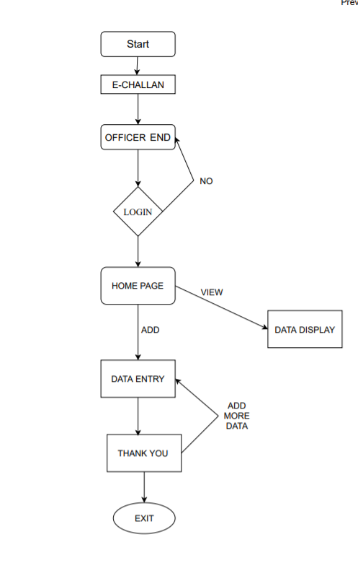

**7.Algorithm**:

a. Login page:

i. The user has to enter his username and password to log in.

ii. The end-user is the cops so this is only there are only a fixed number of users who can access them so they can’t add new users unless they contact higher authorities.

iii. After entering the correct username and password, they will log in and redirect to the homepage.

b. Homepage:

i. After login they enter into the homepage, the user has to enter the vehicle number.

ii. They will have 2 options, either to view their challan or update a new challan.

iii. After clicking on view, the user can view the following details regarding the challan I.D, vehicle number, violation, location, amount, date and time, image.

iv. After clicking on update, the page will be redirected to a new page where the police have to upload the details like I.D, vehicle number, violation, location, amount, date and time, image.

v. After submitting the data, you will be redirected to a thank you page.

vi. There will be a button called to add more data where the user will be redirected to the upload page.

c. Thank you page,

i. After entering the details of the new challan, the user will be redirected to a thank you page where the user will have

1) **login page**

If the login credentials are valid it will redirect to the home page.

To login the default credentials as of now are:

Username: user1

Password:123456

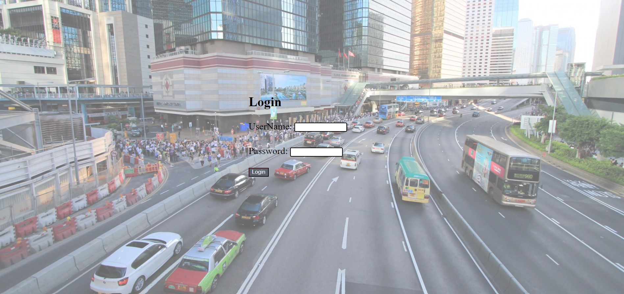

2)**Home Page**

There is a choice here if you want to add data you can press the add button and it will redirect to the data entry page if you want to view the pending challan you can type the vehicle number and press the view button it will redirect you to the data entry page.

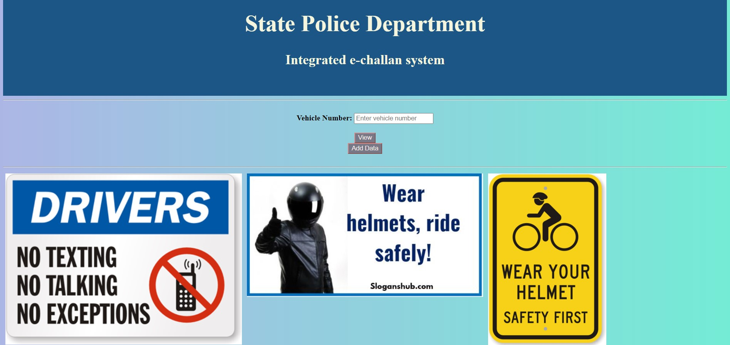

3)**Data Entry page**

You can fill the columns, the data entered here is stored in the "detentry" table of the database.

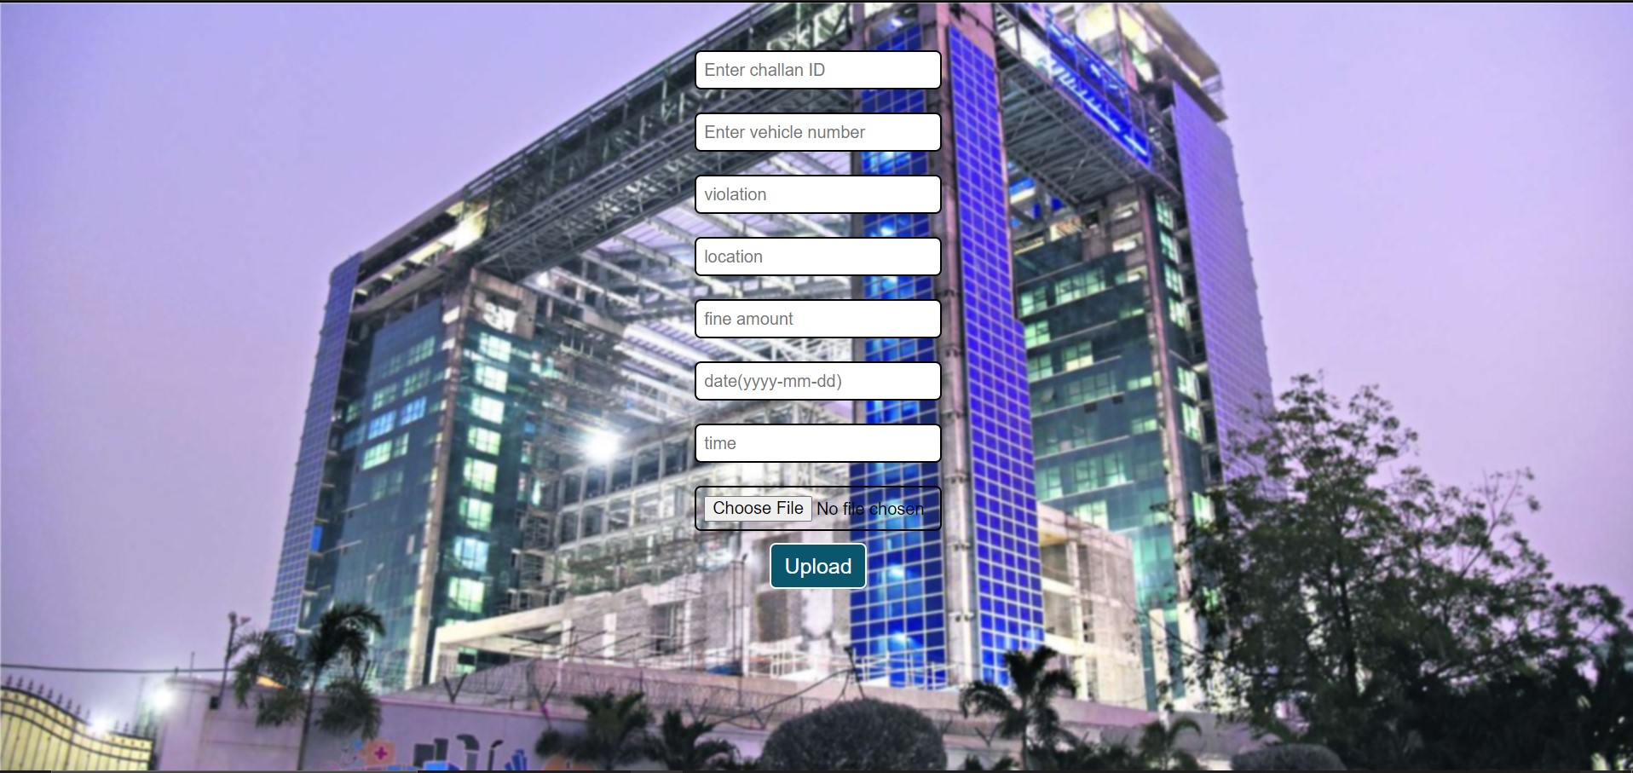

4)**Data Display page**

The challan details are displayed here you can also check the image by clicking on it.

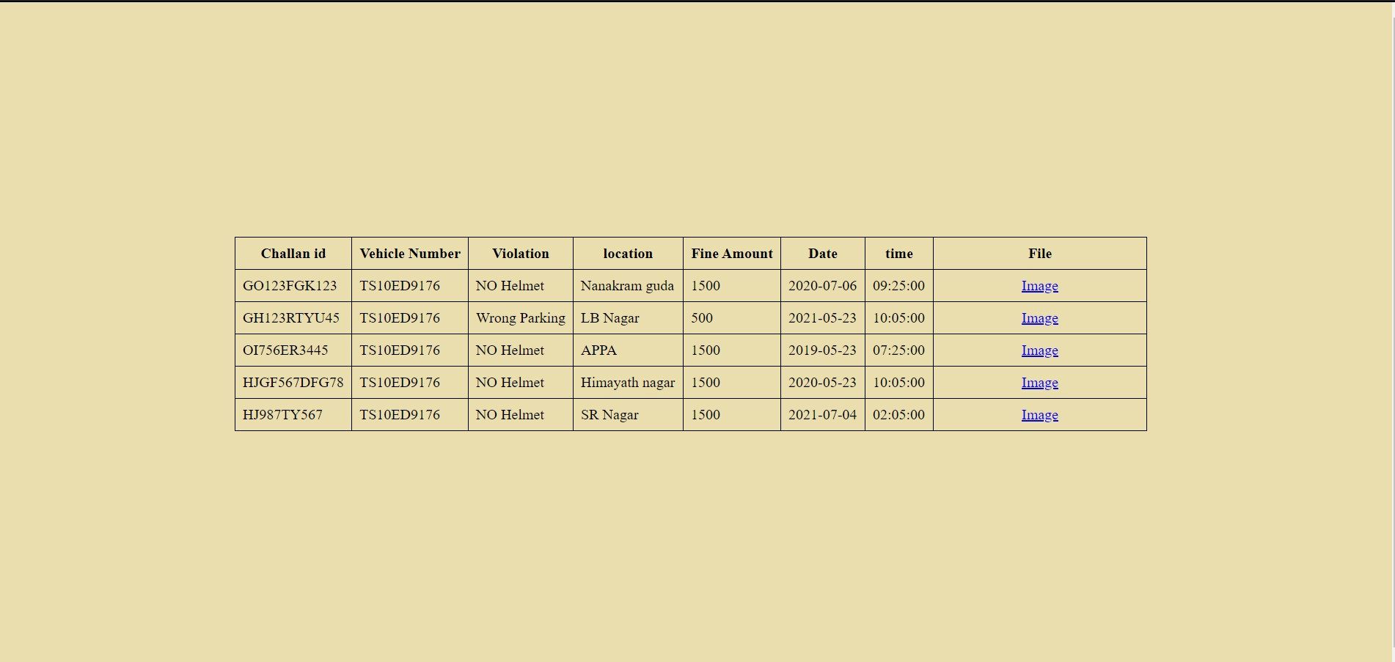

5)**Thank you page**

If you want to quit you can close the tab. If you want to add more data you can click on it, it will redirect you to the data entry page.

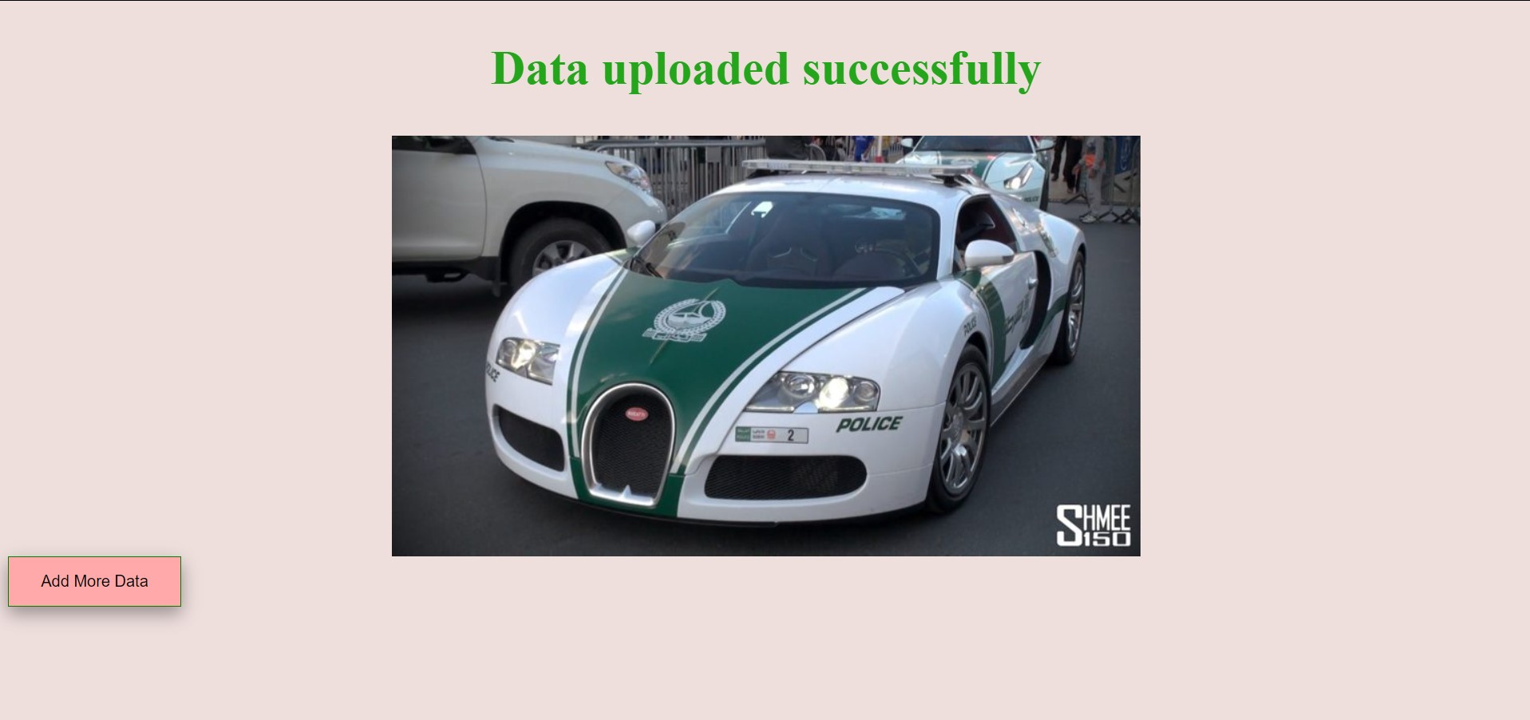

6) **Database table of login details**

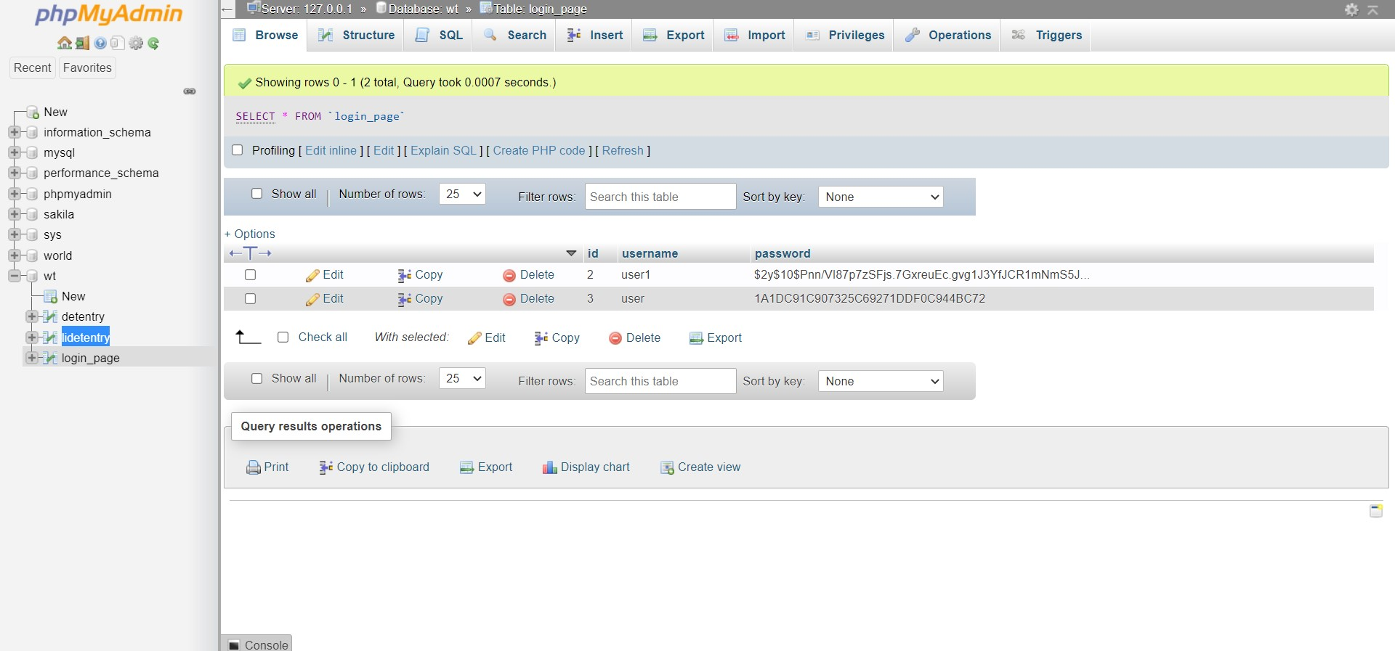

7) **Database table of vehicle details**

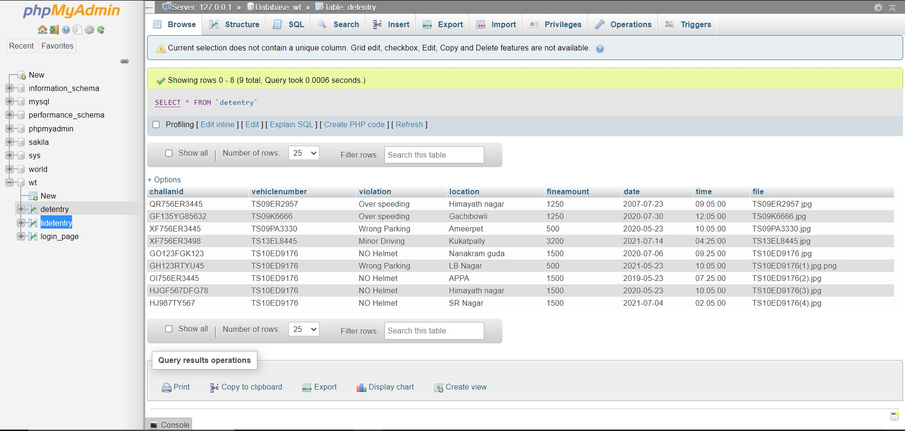

**Conclusion:**

Our project is an E-Challan system of the traffic department built using HTML, CSS, JavaScript along with MYSQL and PHP. Our work is to build only the Officers view, one who has the login credentials can add or view data. One can also add an image as evidence. As an online platform, official officer from anywhere can add data.